Week 8

Web programming

23BCE5142

Harini S

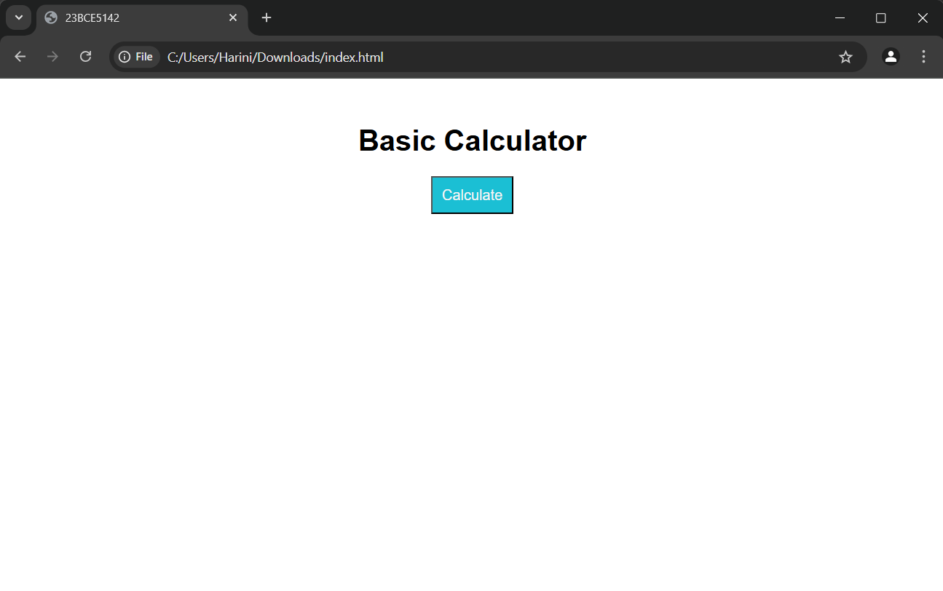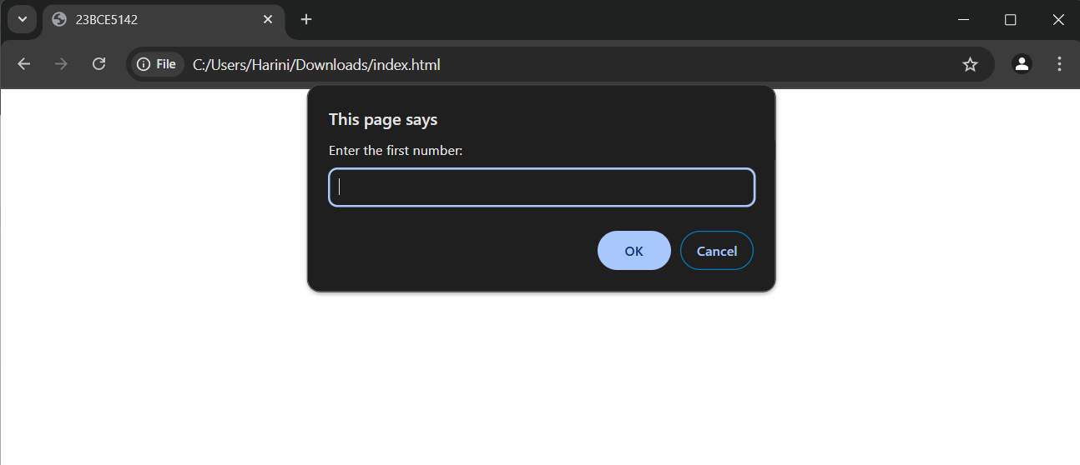

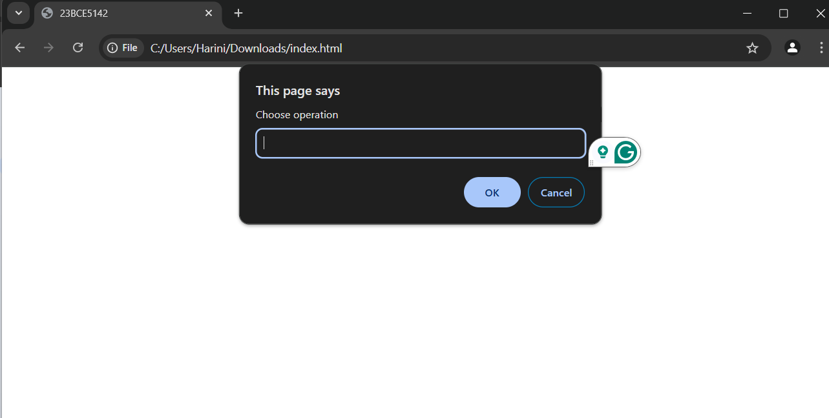

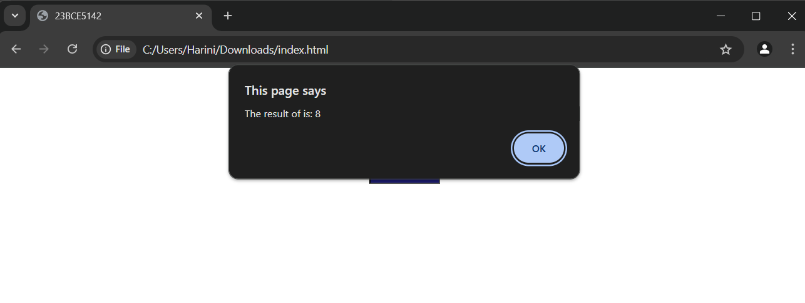

<html>

<head>

    <title>23BCE5142</title>

    <link rel="stylesheet" href="style.css">

</head>

<body>

    <h1>Basic Calculator</h1>

    <button onclick="performCalculation()">Calculate</button>

    <script src="calc.js"></script>

</body>

</html>

body {

    font-family: Arial;

    text-align: center;

    margin-top: 50px;

}

button {

    padding: 10px;

    font-size: 16px;

    background-color: #1bbfd4;

    color: rgb(247, 245, 245);

}

button:hover {

    background-color: #1a196b;

}

function performCalculation() {

    const num1 = parseFloat(prompt("Enter the first number:"));

    const num2 = parseFloat(prompt("Enter the second number:"));

    if (isNaN(num1) || isNaN(num2)) {

        alert("Please enter valid numbers.");

        return;

    }

    const operation = prompt("Choose operation");

    let result;

    switch (operation) {

        case "+":

            result = num1 + num2;

            break;

        case "-":

            result = num1 - num2;

            break;

        case "\*":

            result = num1 \* num2;

            break;

        case "/":

            if (num2 !== 0) {

                result = num1 / num2;

            } else {

                alert("Cannot divide by zero.");

                return;

            }

            break;

        case "%":

            result = num1 % num2;

            break;

        default:

            alert("Invalid operation selected.");

            return;

    }

    alert(`The result of is: ${result}`);

}

function agechk(){

    const age = parseFloat(prompt("Enter the age:"));

    if (isNaN(age) || age<0) {

        alert("Please enter valid age.");

        return;

    }

    if(age>=18){

        alert("Can drive");

        return;

    }

    else{

        alert("Cannot drive");

        return;

    }

}

function chkStudent() {

    let isStudent = confirm("Are you a student?");

    if (isStudent) {

        let regNumber = prompt("Enter your registration number:");

        if (regNumber) {

            alert("Registration number has been recorded.");

        } else {

            alert("Enter a  valid registration number.");

        }

    } else {

        alert("You are not a student.");

    }

}

function calculateTotal() {

    let adults = document.getElementById("adultTickets").value;

    let children = document.getElementById("childTickets").value;

    adults = parseInt(adults) || 0;

    children = parseInt(children) || 0;

    let total = (adults \* 10) + (children \* 5);

    document.getElementById("totalAmount").value = "₹" + total;

}

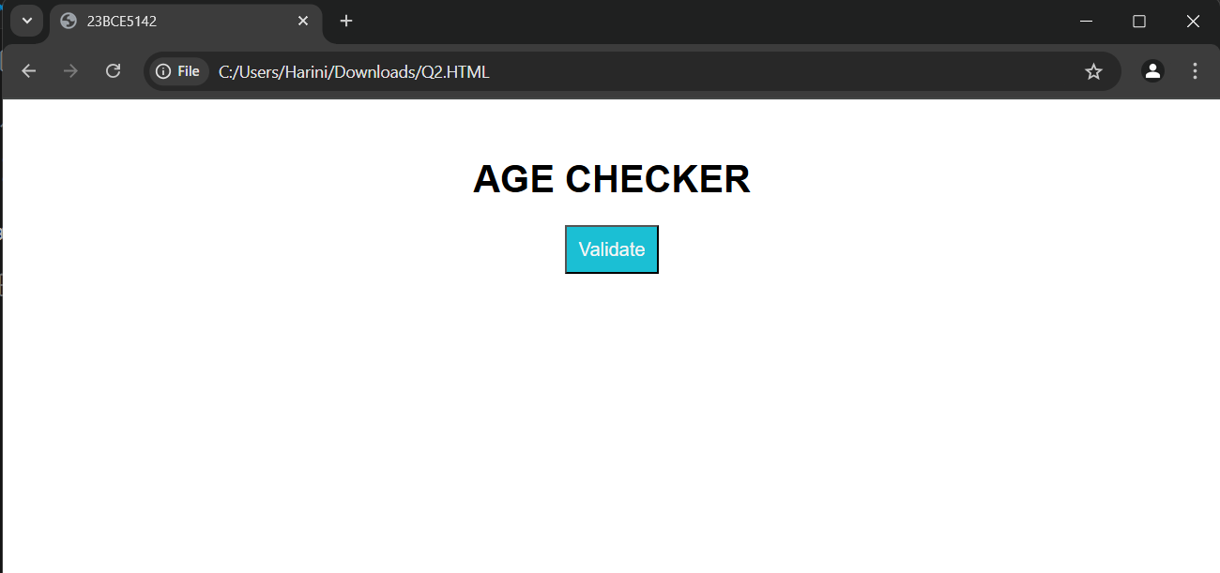

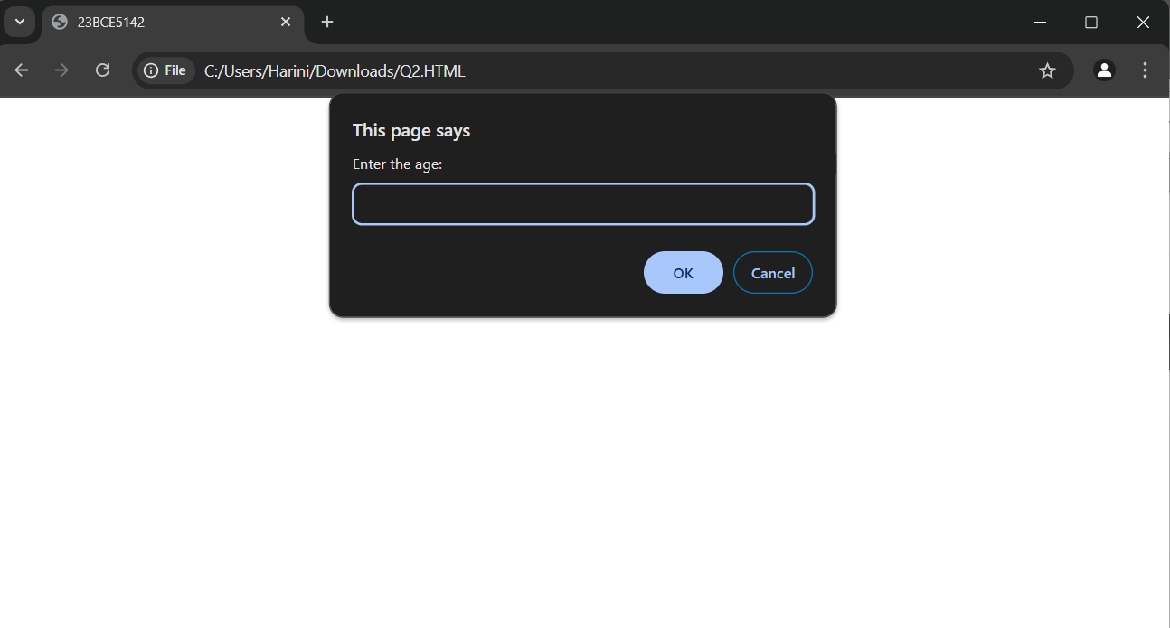

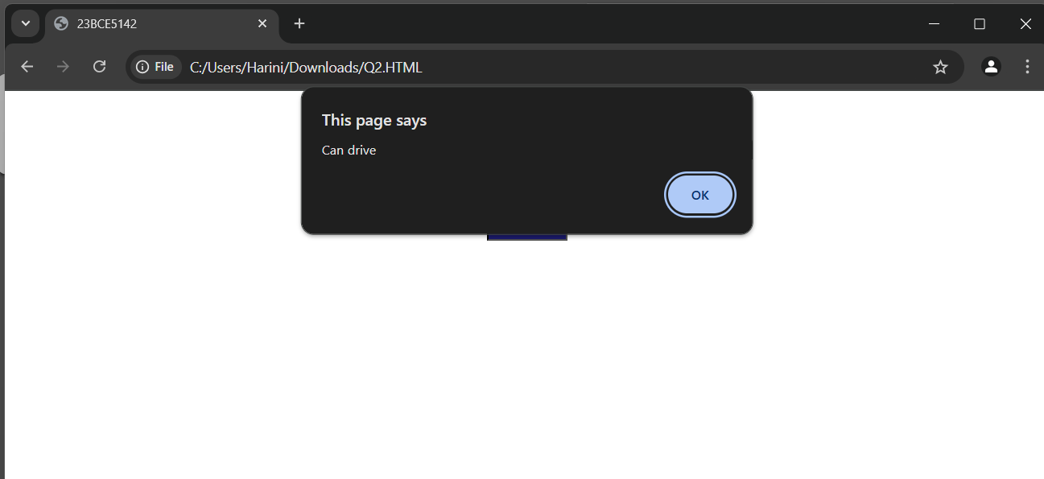

<html>

<head>

    <title>23BCE5142</title>

    <link rel="stylesheet" href="style.css">

</head>

<body>

    <h1>AGE CHECKER</h1>

    <button onclick="agechk()">Validate</button>

    <script src="calc.js"></script>

</body>

</html>

function performCalculation() {

    const num1 = parseFloat(prompt("Enter the first number:"));

    const num2 = parseFloat(prompt("Enter the second number:"));

    if (isNaN(num1) || isNaN(num2)) {

        alert("Please enter valid numbers.");

        return;

    }

    const operation = prompt("Choose operation");

    let result;

    switch (operation) {

        case "+":

            result = num1 + num2;

            break;

        case "-":

            result = num1 - num2;

            break;

        case "\*":

            result = num1 \* num2;

            break;

        case "/":

            if (num2 !== 0) {

                result = num1 / num2;

            } else {

                alert("Cannot divide by zero.");

                return;

            }

            break;

        case "%":

            result = num1 % num2;

            break;

        default:

            alert("Invalid operation selected.");

            return;

    }

    alert(`The result of is: ${result}`);

}

function agechk(){

    const age = parseFloat(prompt("Enter the age:"));

    if (isNaN(age) || age<0) {

        alert("Please enter valid age.");

        return;

    }

    if(age>=18){

        alert("Can drive");

        return;

    }

    else{

        alert("Cannot drive");

        return;

    }

}

function chkStudent() {

    let isStudent = confirm("Are you a student?");

    if (isStudent) {

        let regNumber = prompt("Enter your registration number:");

        if (regNumber) {

            alert("Registration number has been recorded.");

        } else {

            alert("Enter a  valid registration number.");

        }

    } else {

        alert("You are not a student.");

    }

}

function calculateTotal() {

    let adults = document.getElementById("adultTickets").value;

    let children = document.getElementById("childTickets").value;

    adults = parseInt(adults) || 0;

    children = parseInt(children) || 0;

    let total = (adults \* 10) + (children \* 5);

    document.getElementById("totalAmount").value = "₹" + total;

}

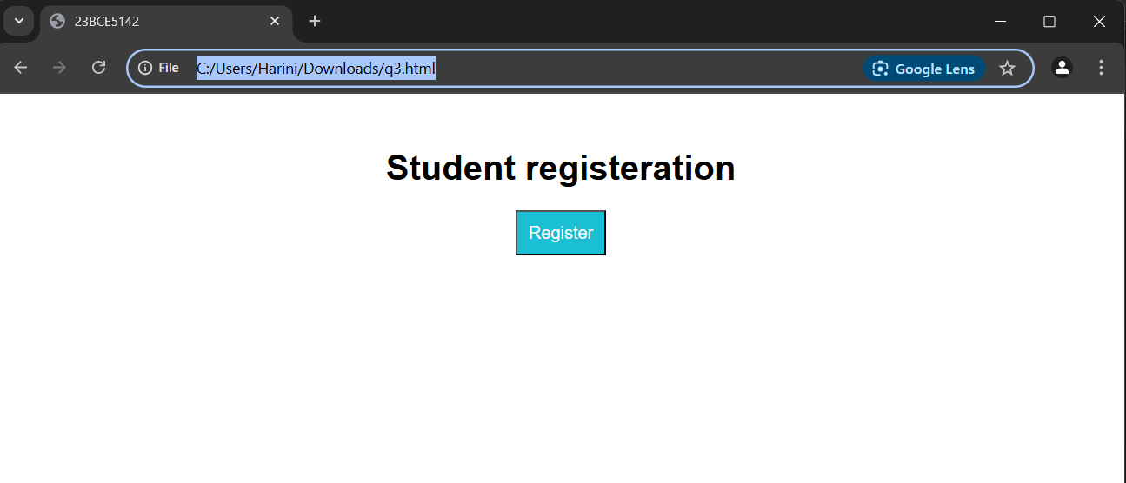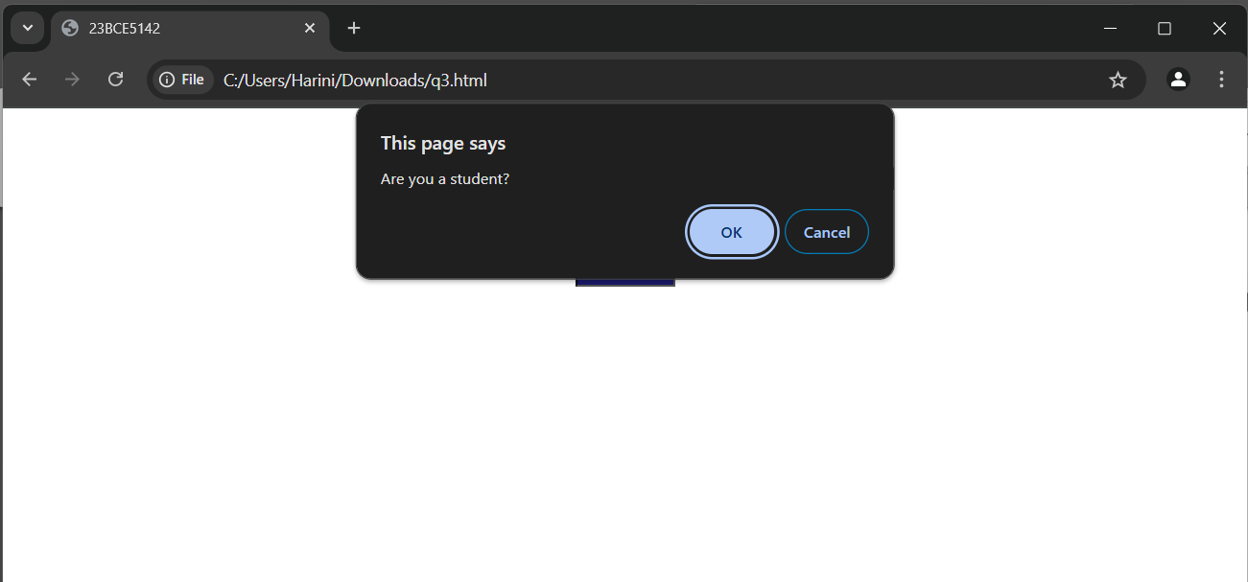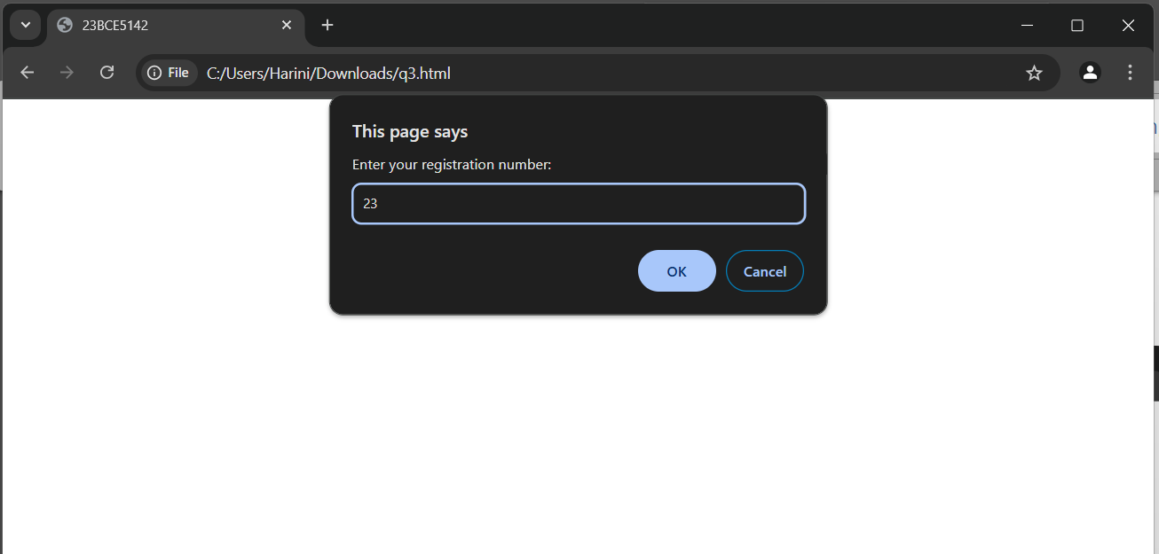

<html>

<head>

    <title>23BCE5142</title>

    <link rel="stylesheet" href="style.css">

</head>

<body>

    <h1>Student registeration</h1>

    <button onclick="chkStudent()">Register</button>

    <script src="calc.js"></script>

</body>

</html>

function performCalculation() {

    const num1 = parseFloat(prompt("Enter the first number:"));

    const num2 = parseFloat(prompt("Enter the second number:"));

    if (isNaN(num1) || isNaN(num2)) {

        alert("Please enter valid numbers.");

        return;

    }

    const operation = prompt("Choose operation");

    let result;

    switch (operation) {

        case "+":

            result = num1 + num2;

            break;

        case "-":

            result = num1 - num2;

            break;

        case "\*":

            result = num1 \* num2;

            break;

        case "/":

            if (num2 !== 0) {

                result = num1 / num2;

            } else {

                alert("Cannot divide by zero.");

                return;

            }

            break;

        case "%":

            result = num1 % num2;

            break;

        default:

            alert("Invalid operation selected.");

            return;

    }

    alert(`The result of is: ${result}`);

}

function agechk(){

    const age = parseFloat(prompt("Enter the age:"));

    if (isNaN(age) || age<0) {

        alert("Please enter valid age.");

        return;

    }

    if(age>=18){

        alert("Can drive");

        return;

    }

    else{

        alert("Cannot drive");

        return;

    }

}

function chkStudent() {

    let isStudent = confirm("Are you a student?");

    if (isStudent) {

        let regNumber = prompt("Enter your registration number:");

        if (regNumber) {

            alert("Registration number has been recorded.");

        } else {

            alert("Enter a  valid registration number.");

        }

    } else {

        alert("You are not a student.");

    }

}

function calculateTotal() {

    let adults = document.getElementById("adultTickets").value;

    let children = document.getElementById("childTickets").value;

    adults = parseInt(adults) || 0;

    children = parseInt(children) || 0;

    let total = (adults \* 10) + (children \* 5);

    document.getElementById("totalAmount").value = "₹" + total;

}

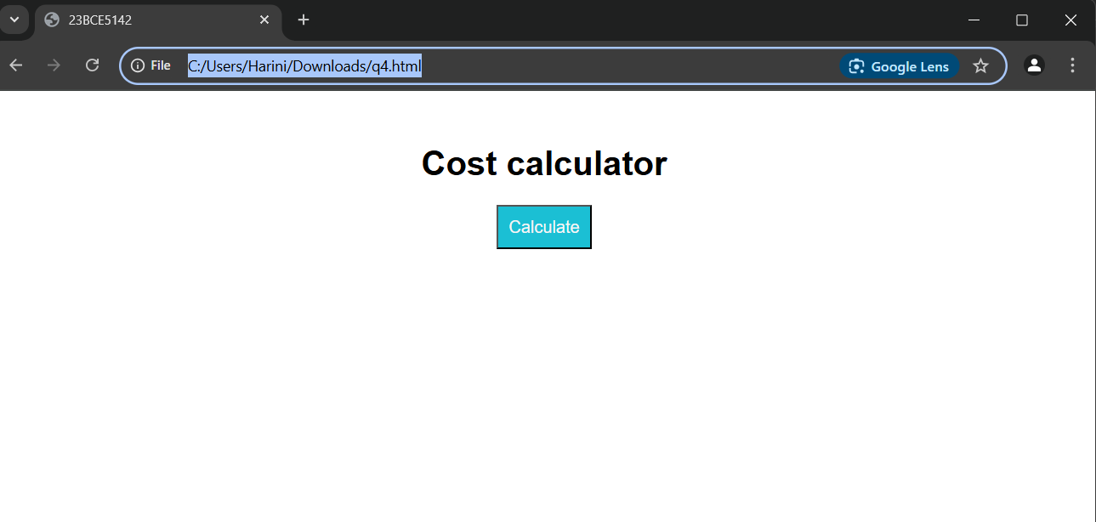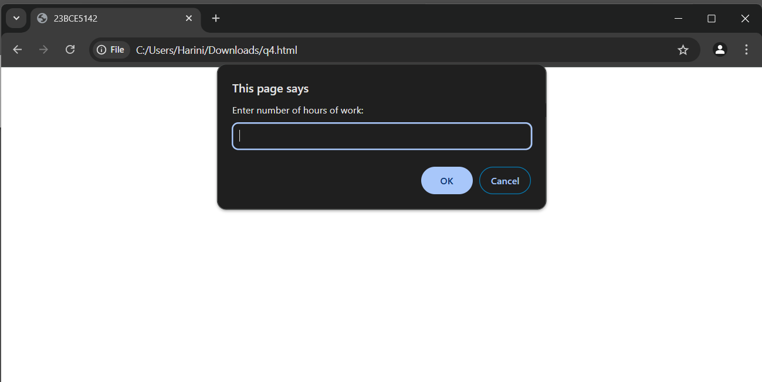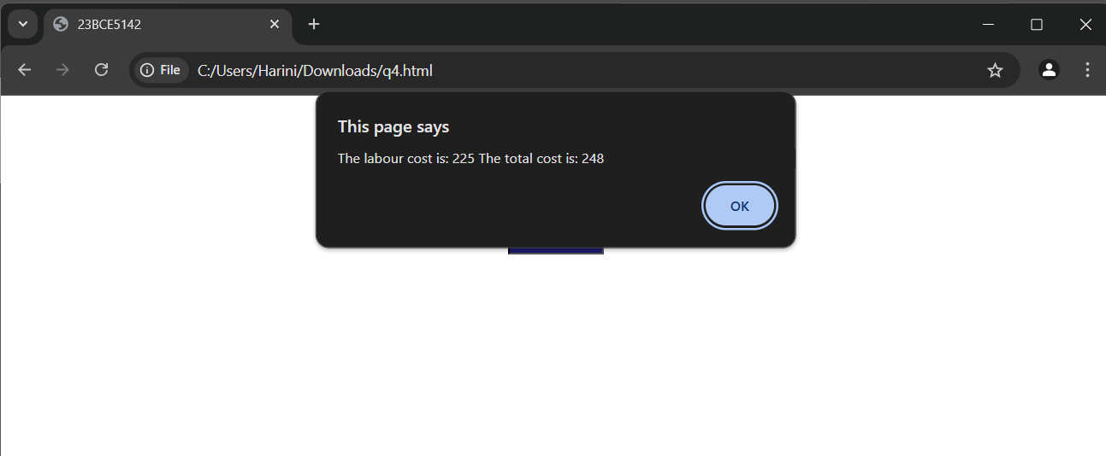<html>

<head>

    <title>23BCE5142</title>

    <link rel="stylesheet" href="style.css">

    <script>

        function costcalc() {

    const hour = parseFloat(prompt("Enter number of hours of work:"));

    const matcost = parseFloat(prompt("Enter material cost:"));

    if (isNaN(hour) || isNaN(matcost)) {

        alert("Please enter valid numbers.");

        return;

    }

    let labcost;

    let totcost;

    labcost = 45\*hour;

    totcost = matcost+labcost;

    alert(`The labour cost is: ${labcost} The total cost is: ${totcost}`);

}

    </script>

</head>

<body>

    <h1>Cost calculator</h1>

    <button onclick="costcalc()">Calculate</button>

</body>

</html>

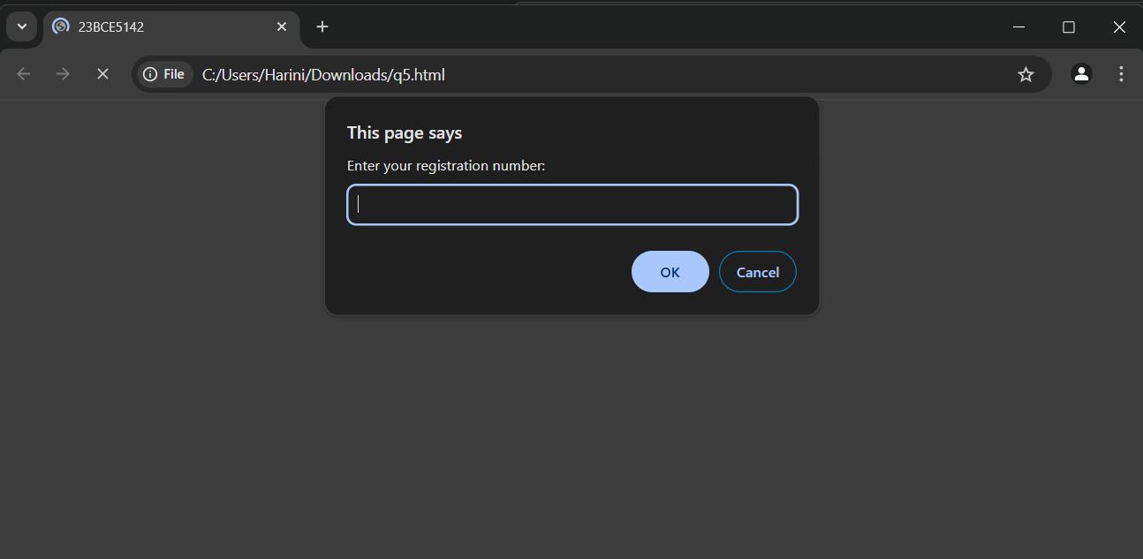

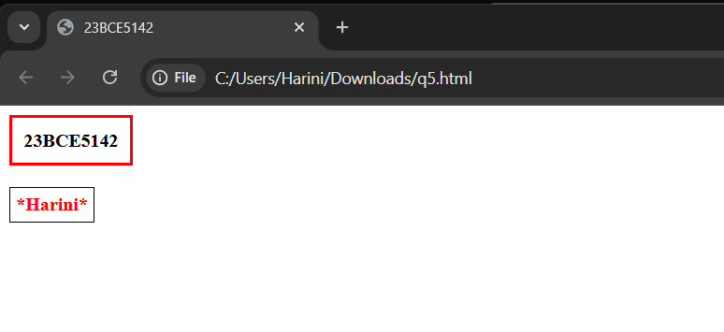<html>

<head>

    <title>23BCE5142</title>

</head>

<body>

    <script>

        let regNo = prompt("Enter your registration number:");

        let name = prompt("Enter your name:");

        document.write(`<div style="border: 3px solid red; display: inline-block; padding: 10px; font-weight: bold; text-align: center;">${regNo}</div><br><br>`);

        document.write('<div id="nameDisplay" style="border: 1px solid black; display: inline-block; padding: 5px; font-weight: bold; text-align: center;"></div>');

        document.getElementById("nameDisplay").innerHTML = `<span style="color: red;">\*${name}\*</span>`;

    </script>

</body>

</html>

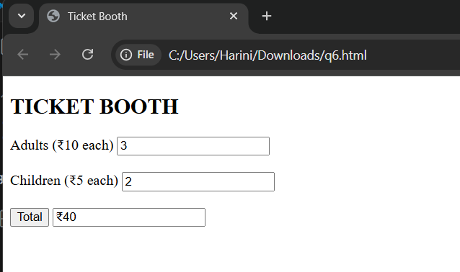

<html>

<head>

    <title>Ticket Booth</title>

    <script src="script.js" defer></script>

</head>

<body>

    <h2>TICKET BOOTH</h2>

    <label for="adults">Adults (₹10 each)</label>

    <input type="number" id="adults" min="0"><br><br>

    <label for="children">Children (₹5 each)</label>

    <input type="number" id="children" min="0"><br><br>

    <button onclick="calculateTotal()">Total</button>

    <input type="text" id="total" readonly>

</body>

</html>

function calculateTotal() {

    let adultCount = document.getElementById("adults").value;

    let childCount = document.getElementById("children").value;

    let totalAmount = (adultCount \* 10) + (childCount \* 5);

    document.getElementById("total").value = "₹" + totalAmount;

}